SUBJECT: Data Structures and Algorithms

Submitted To: Dr. Mohsin Ali Memon

Submitted By: Asadullah Samo (21SW036)

Section: Section-III

Dated: 12/03/2023

Assignment: Problem Based Assignment

**Note: For all supporting files used in this project refer to**

<https://github.com/AsadullahSamo/DSA/tree/main/DSA%20Project/src>

Be sure to download these files to run project without errors

**Step 01:**

Use [Reverse Geocoding library for Java (daniel-braun.com)](https://www.daniel-braun.com/technik/reverse-geocoding-library-for-java/) library to find out the city and country from the given coordinates and store them in yearly earthquake collection along with magnitude. (Collection of each year means 52 collections)

Source Code:

**import** eu.bitm.NominatimReverseGeocoding.Address;

**import** eu.bitm.NominatimReverseGeocoding.NominatimReverseGeocodingJAPI;

**import** java.io.*;

**import** java.nio.charset.StandardCharsets;

**import** java.sql.*;

**import** java.util.ArrayList;

**import** java.util.Scanner;

**class** Step1 {

**public** ArrayList<String>[] getArrayList(){

// 53 objects of arraylist for 52 countries (one extra object to avoid indexOutofBounds Exception )

ArrayList<String>[] arrayList = **new** ArrayList[53];

**for** (**int** i = 0; i < arrayList.length; i++) {

arrayList[i] = **new** ArrayList<>();

}

**int** index = 0;

**try**{

// Read Yearly Earthquake.txt from respective location

BufferedReader br = **new** BufferedReader(**new** InputStreamReader(**new** FileInputStream("E:\\DSA\\DSA Project\\src\\Files\\Yearly Earthquake.txt"), StandardCharsets.***UTF_8***));

String line;

**while** ((line = br.readLine())!=**null**){

String [] array = line.split(", "); // if , is encountered in line, split it and store in array

**if** (index==52){

**break**;

}

**for** (**int** i=0; i< array.length; i++) {

arrayList[index].add(array[i]); // add every element of array to arrayList[index]

}

index++; // when line ends, change index to new object

}

} **catch** (IOException e) {

**throw** **new** RuntimeException(e);

}

**return** arrayList;

} // end of getArrayList() method

**public** **void** getAllCountriesForYear(){

ArrayList<String>[] arrayList = getArrayList();

Scanner sc = **new** Scanner(System.***in***);

System.***out***.print("Enter the year to get all countries with cities and magnitude: ");

**int** year = sc.nextInt();

System.***out***.println(arrayList[year-1965]); // As the year starts from 1965, and array from 0, so year 1965 gets index 0, 1966 gets index 1 and so on

} // end of getAllCountriesForYear() method

// To get average number of earthquakes for a country, we use below method

**public** **void** getEarthquakesForACountry(){

Scanner sc = **new** Scanner(System.***in***);

ArrayList<String>[] arrayList = getArrayList();

System.***out***.print("Enter year: ");

**int** year = sc.nextInt();

sc.nextLine();

System.***out***.print("Enter the country name: ");

String con = sc.nextLine();

System.***out***.print("[");

String [] array = arrayList[year - 1965].toArray(**new** String[0]);

**for** (**int** i=0; i<array.length; i++){

**if** (array[i].contains(con))

System.***out***.print(array[i]+", "); // Search for country in year

}

System.***out***.println("]");

} // end of getEarthquakesForACountry() method

} // end of class Step1

OUTPUT:



**Step 02:**

Make a queue storing biggest (with highest magnitude) quake of each year with magnitude and country, starting from 1965 to 2016. (52 elements in the queue approx.).

Source Code:

**import** java.io.BufferedReader;

**import** java.io.FileReader;

**import** java.io.IOException;

**import** java.util.LinkedList;

**import** java.util.Queue;

**import** java.util.Scanner;

**class** Step2 {

**public** Queue<Object> addCountryWithLargestMagnitude(){

Queue<Object> largestMagnitude = **new** LinkedList<>();

**try** {

// Read “Max Magnitude For Queue.txt” from respective location

BufferedReader br = **new** BufferedReader(**new** FileReader("E:\\DSA\\DSA Project\\src\\Files\\Max Magnitude For Queue.txt"));

**int** c;

StringBuilder line = **new** StringBuilder();

**while** ((c = br.read()) != -1) {

**if** (c == '\n') { // End of line reached, So add magnitude and country in Queue

largestMagnitude.add(String.*valueOf*(line));

line.setLength(0); // Reset the line buffer for the next line

} **else** {

// Add the current character to the line (StringBuilder)

line.append((**char**) c);

}

} // end of while loop

} **catch** (IOException ie){

ie.printStackTrace();

} // end of try catch block

**return** largestMagnitude;

} // end of addCountryWithLargestMagnitude() method

**public** **void** getLargestMagnitudeForEachCountry(){

Queue<Object> largestMagnitude = addCountryWithLargestMagnitude();

Object [] array = largestMagnitude.toArray(); // convert queue to array, to apply index accessing operations

System.***out***.println(largestMagnitude); // Print entire queue

System.***out***.println("The size of queue is " + largestMagnitude.size());

Scanner sc = **new** Scanner(System.***in***);

System.***out***.println("Enter the year to get its largest magnitude and country: ");

**int** year = sc.nextInt();

System.***out***.println(array[year-1965]); // as year starts from 1965 and index, from 0 so year 1965 gets 0 index

} // end of getLargestMagnitudeForEachCountry() method

// Get the largest magnitude from starting to ending year, USING BELOW METHOD

**public** **void** getLargestMagnitudeForListOfCountries(){

Queue<Object> largestMagnitude = addCountryWithLargestMagnitude();

Object [] array = largestMagnitude.toArray(); // convert queue to array, to apply index accessing operations

Scanner sc = **new** Scanner(System.***in***);

**int** start, end;

System.***out***.print("Enter starting year: ");

start = sc.nextInt();

System.***out***.print("Enter ending year: ");

end = sc.nextInt();

System.***out***.print("[");

**for** (**int** i=start; i<=end; i++){

**if** (i==end){

System.***out***.print(array[i-1965]);

} **else** {

System.***out***.print(array[i-1965] + ", ");

}

} // end of for loop

System.***out***.println("]");

} // end of getLargestMagnitudeForListOfCountries() method

} // end of class Step2

OUTPUT:

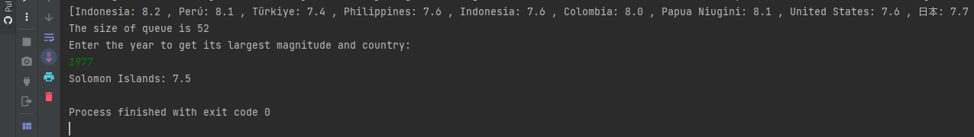

**Step 03:**

Make a stack from the collections, one for each country which stores earthquake and its magnitude in the order of the event (the most recent event on top).

Source Code:

**import** java.io.*;

**import** java.nio.charset.StandardCharsets;

**import** java.sql.*;

**import** java.util.Scanner;

**import** java.util.Stack;

**class** Step3{

// Find index of given country

**public** **int** getIndex(String country){

String [] countries = {"United States", "中国", "Indonesia", "ایران", "Philippines", "Chile", "Vanuatu",

"臺灣", "Papua Niugini", "Ελλάς", "Argentina", "नेपाल", "日本", "México", "República Dominicana",

"Solomon Islands", "South Georgia and the South Sandwich Islands", "Colombia", "Perú",

"Antigua and Barbuda", "Zambia", "Guatemala", "မြန်မာ", "République démocratique du Congo",

"New Zealand/Aotearoa", "Venezuela", "Монгол улс ᠮᠤᠩᠭᠤᠯ ᠤᠯᠤᠰ", "Bolivia", "Россия",

"Türkiye", "Тоҷикистон", "France", "Brasil", "India", "Ecuador", "Tonga", "Viti", "Australia",

"Panamá", "Belau", "Canada", "Ísland", "افغانستان", "پاکستان", "འབྲུགཡུལ་", "Costa Rica",

"Nicaragua", "British Indian Ocean Territory", "Shqipëria", "ኢትዮጵያ", "مصر", "Italia",

"South Africa", "El Salvador", "Bosna i Hercegovina / Босна и Херцеговина", "Кыргызстан",

"Oʻzbekiston", "Djibouti جيبوتي", "Қазақстан", "România", "ประเทศไทย", "Madagasikara / Madagascar",

"Gabon", "Norge", "Cuba", "España", "Tanzania", "België / Belgique / Belgien", "Malaysia", "Србија",

"Crna Gora / Црна Гора", "ኤርትራ Eritrea إرتريا", "Algérie / ⵍⵣⵣⴰⵢⴻⵔ / الجزائر", "Việt Nam",

"ປະເທດລາວ", "Polska", "Honduras", "العراق", "Türkmenistan",

"Saint Kitts and Nevis", "Guinée", "اليمن", "საქართველო", "বাংলাদেশ",

"Kalaallit Nunaat", "Malawi", "Portugal", "Kenya", "South Sudan", "Micronesia",

"България", "Uganda", "Hrvatska", "Maroc / ⵍⵎⵖⵔⵉⴱ / المغرب", "Jamaica", "السودان",

"Trinidad and Tobago", "Հայաստան", "Северна Македонија", "Paraguay / Paraguái", "Κύπρος - Kıbrıs",

"السعودية", "Dominica", "Azərbaycan", "سوريا", "Soomaaliya الصومال", "Slovenija", "Kosova / Kosovo",

"Moçambique", "Ayiti", ""};

**for** (**int** i=0; i<countries.length; i++){

**if** (countries[i].equals(country)){

**return** i;

}

} // end of for loop

**return** -1;

} // end of getIndex() method

**public** Stack<Object>[] getStack() **throws** SQLException, ClassNotFoundException, IOException {

Stack<Object>[] stack = **new** Stack[110]; // As there are 110 countries, so stack has 110 objects, one for each country

**for** (**int** i=0; i<stack.length; i++){

stack[i] = **new** Stack<>(); // initialize all 110 objects

}

**int** index = 0;

**try** {

// Read from "Stack.txt" from respective location

BufferedReader br = **new** BufferedReader(**new** InputStreamReader(**new** FileInputStream("E:\\DSA\\DSA Project\\src\\Files\\Stack.txt"), StandardCharsets.***UTF_8***));

String line;

**while** ((line = br.readLine()) != **null**) { // Read entire line

String[] details = line.split(","); // split the line by commas and store entire string to array after , is encountered

**for** (**int** i=0; i<details.length; i++) {

stack[index].push(details[i]); // Put entire details array index by index to object of stack

}

index++; // now storing occurs in next stack object

} // end of while loop

} **catch** (IOException e) {

**throw** **new** RuntimeException(e);

} // end of try catch block

**return** stack;

} // end of method getStack()

**public** **void** getDetailsOfCountry() **throws** SQLException, ClassNotFoundException, IOException {

Stack<Object>[] stack = getStack();

// System.out.println(stack.length);

Scanner sc = **new** Scanner(System.***in***);

System.***out***.println("Enter the name of country to get its details: ");

String con = sc.nextLine();

**int** i = getIndex(con);

**while** (i==-1) { // loop till valid country is provided

**if** (i == -1) {

System.***out***.println("Please enter valid country name: ");

}

System.***out***.println("Enter the name of country to get its details: ");

con = sc.nextLine();

i = getIndex(con);

} // end of while loop

System.***out***.println(stack[i]); // Print details of country with magnitude from 1965 to 2016 (recent event on top)

} // end of getDetailsOfCountry() method

// Get n recent earthquakes through below method for particular country

**public** **void** getNRecentEarthqakesForEachCountry() **throws** SQLException, IOException, ClassNotFoundException {

Stack<Object>[] stack = getStack();

Scanner sc = **new** Scanner(System.***in***);

System.***out***.println("Enter the name of country you want to get earthquakes of: ");

String country = sc.nextLine();

System.***out***.println("How many recent earthquakes you want to get? ");

**int** recentN = sc.nextInt();

**int** index = getIndex(country);

Object[] array = stack[index].toArray(); // convert that entire stack object to array to apply index accessing operations

**int** num = array.length - recentN; // used as starting index for loop

System.***out***.println("Recent "+recentN+" earthquakes are ");

System.***out***.print("[");

**for** (**int** i=num; i<array.length; i++){

**if** (i==array.length-1)

System.***out***.print(array[i]);

**else**

System.***out***.print(array[i] + ", ");

} // end of for loop

System.***out***.println("]");

} // end of getNRecentEarthquakesForEachCountry() method

// Stack object with most size will be most vulnerable to earthquakes

**public** **int** mostNumberOfEarthquakes() **throws** SQLException, IOException, ClassNotFoundException {

Stack<Object>[] stack = getStack();

**int** max = stack[0].size();

String str = "";

**for** (**int** i=1; i<stack.length; i++){

**if** (stack[i].size() > max){

max = stack[i].size(); // if any object's size is greater that first object's size, assign max to this object

str = (String) stack[i].peek(); // get top of stack

str = str.substring(0, str.indexOf(":")); // get country from str, which is found when : is encountered (For more help refer to Stack.txt)

}

} // end of for loop

System.***out***.println("Most vulnerable country is "+str);

**return** max;

} // end of mostNumberOfEarthquakes() method

} // end of class Step3

OUTPUT:

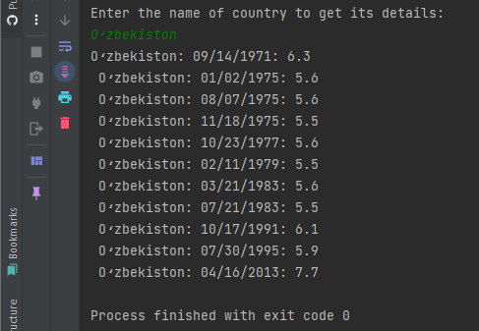

**Step 04:**

Make a linked list which saves the one most recent earthquake with magnitude and country name from each country (use the stack from step 3).

Source Code:

**import** java.io.IOException;

**import** java.sql.SQLException;

**import** java.util.LinkedList;

**import** java.util.Scanner;

**import** java.util.Stack;

**class** Step4 {

**public** **void** getRecentEventForEachCountry() **throws** SQLException, ClassNotFoundException, IOException {

Step3 step3 = **new** Step3();

Stack<Object>[] stack = step3.getStack(); // call getStack() from step3 class

LinkedList<Object> linkedList = **new** LinkedList<>();

**for** (**int** i=0; i<stack.length; i++){

linkedList.add(stack[i].peek());

}

Scanner sc = **new** Scanner(System.in);

System.out.println("Enter the name of country to get its recent event: ");

String country = sc.nextLine();

**int** index = step3.getIndex(country);

**if**(index!=-1) {

System.out.println("Recent earthquake is " + linkedList.get(index));

}

} // end of getRecentEventForEachCountry() method

**public** **void** getEarthquakesForParticularMagnitudeRange() **throws** SQLException, IOException, ClassNotFoundException {

Step3 step3 = **new** Step3();

Stack<Object>[] stack = step3.getStack(); // call getStack() from step3 class

LinkedList<Object> linkedList = **new** LinkedList<>();

**for** (**int** i=0; i<stack.length; i++){

linkedList.add(stack[i].peek());

}

Scanner sc = **new** Scanner(System.***in***);

System.***out***.println("Enter the magnitude to get earthquakes above this magnitude: ");

**double** userMag = sc.nextDouble();

**for** (**int** i=0; i<linkedList.size(); i++){

String str = linkedList.get(i).toString();

**double** magnitude = Double.*parseDouble*(str.substring(str.length()-3)); // As magnitude is at last of every string in node, we extracted it using substring from last

**if** (magnitude > userMag){

System.***out***.println(linkedList.get(i));

}

} // end of for loop

} // end of getEarthquakesForParticularMagnitudeRange() method

} // end of class Step 4

OUTPUT:

**Note:** **Entire project.java file which contains all problems and steps execution**

**Problem 01:**

How to find the average number of earthquakes per year for each country and which country is most vulnerable to earthquakes (which country has the greatest number of earthquakes)?

Source Code:

// Average number of earthquakes for a country

public class Project{

public static void main(String [] args){

Step1 step1 = new Step1();

step1.getEarthquakesForACountry

// (Click here to Navigate to this method definition)

// Most Vulnerable country

Step1 step3 = new Step3();

System.out.println("with earthquakes " + step3.mostNumberOfEarthquakes());

// (Click here to navigate to method definition)

} // end of main() method

} // end of program

OUTPUT:

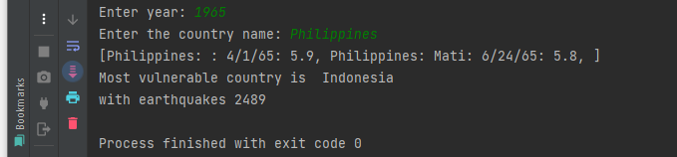

**Problem 02:**

Which are the biggest earthquakes from 2005 to 2015 and occurred and in which country (use step 2)? Source Code:

**public** **class** Project{

**public** **static** **void** main(String [] args) {

Step2 step2 = **new** Step2();

step2.getLargestMagnitudeForListOfCountries(); // (Click here to navigate to method definition)

}

}

OUTPUT:

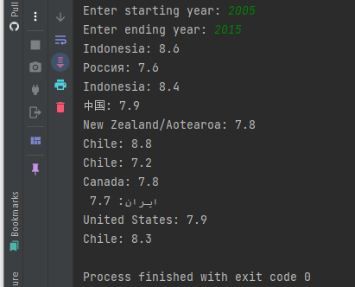

**Problem 03:**

How to determine the recent 5 earthquakes from each country?

Source Code:

**public** **class** Project{

**public** **static** **void** main(String [] args) {

// Problem 3: Recent n earthquakes for a given country

Step3 step3 = **new** Step3();

step3.getNRecentEarthqakesForEachCountry(); // (Click here to navigate to this method's definition)

} // end of main() method

} // end of program

OUTPUT:

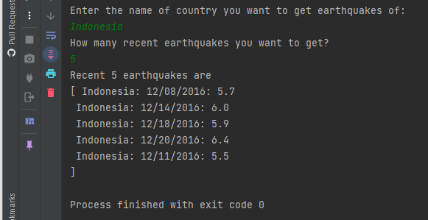

**Problem 04:**

How to find the most recent above 6 magnitude earthquakes (use step 4).

Source Code:

**public** **class** Project{

**public** **static** **void** main(String [] args) {

// Problem 04: Recent earthquakes for a particular magnitude

Step4 step4 = **new** Step4();

step4.getEarthquakesForParticularMagnitudeRange(); // (Click here to navigate to this method's definition)

} // end of main() method

} // end of program

OUTPUT:

